Appendix C - Evidence of using VCS (Version Control Software)

Version Control Software used : TortoiseSVN and Github

Screenshot #1 - Contents in the VCS's **Root Folder** containing all **Repository Project Files**

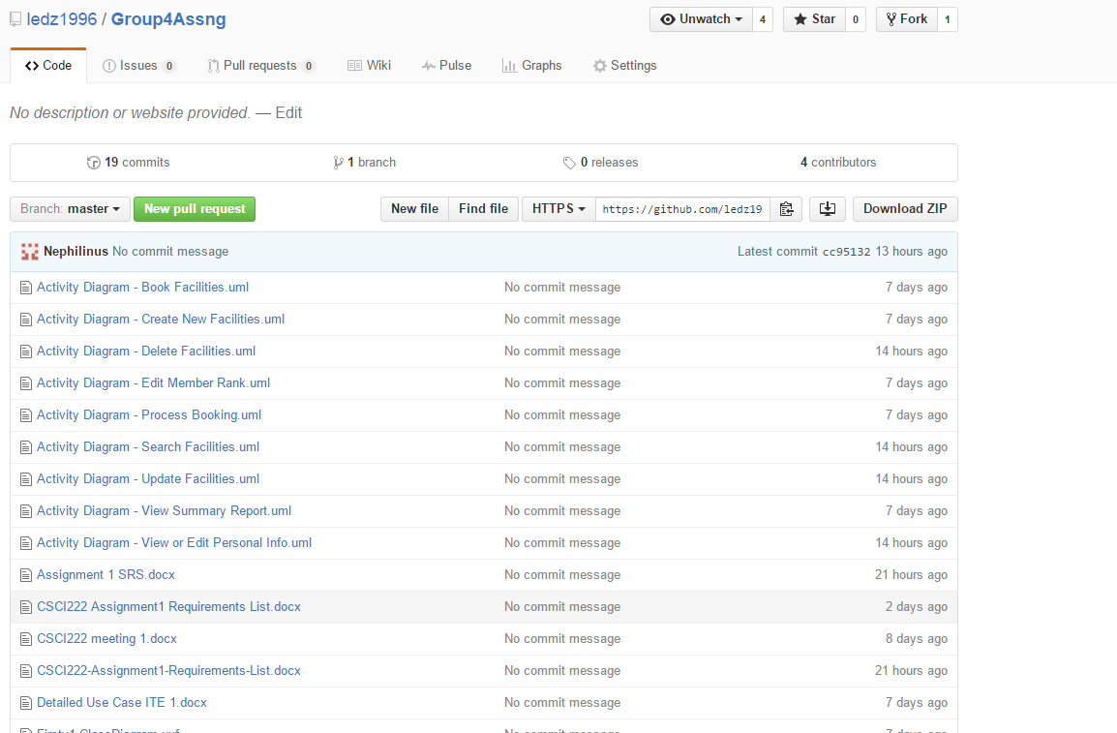

Screenshot #2 - VCS's listing of all the **latest source files currently being managed**

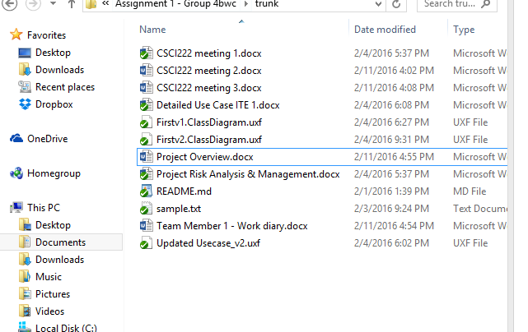

Screenshot #3 - Example using VCS's to **check-out source files** (it may be necessary to do >1 screen capture, depending on the software used)

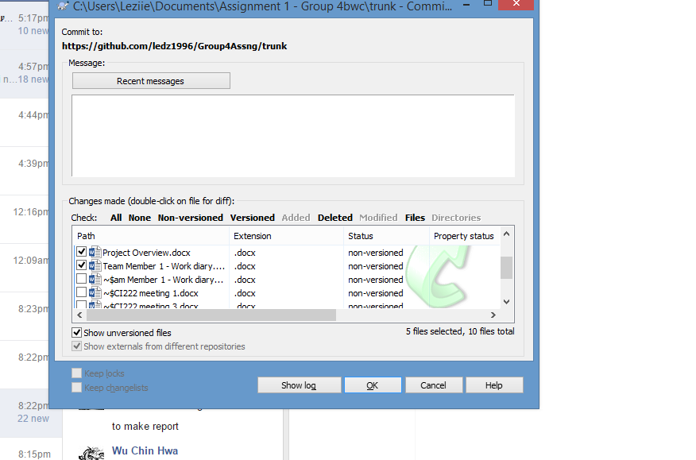

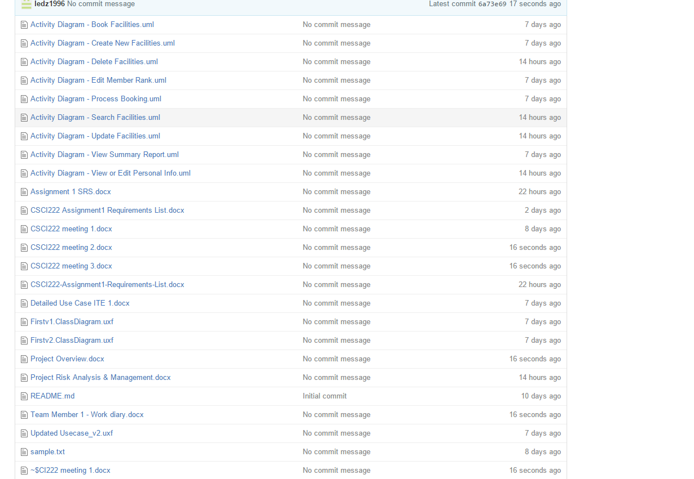

Screenshot #4 - Example using VCS's to **check-in source files** (it may be necessary to do >1 screen capture, depending on the software used)

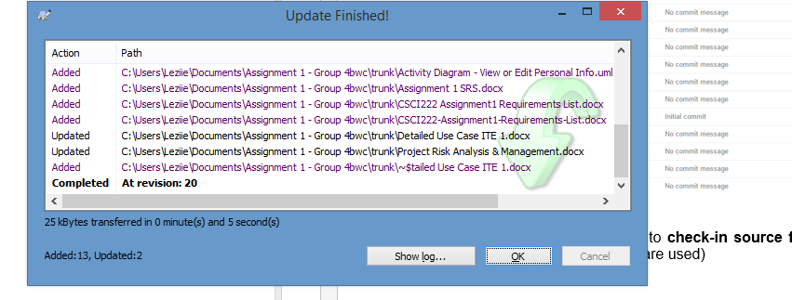

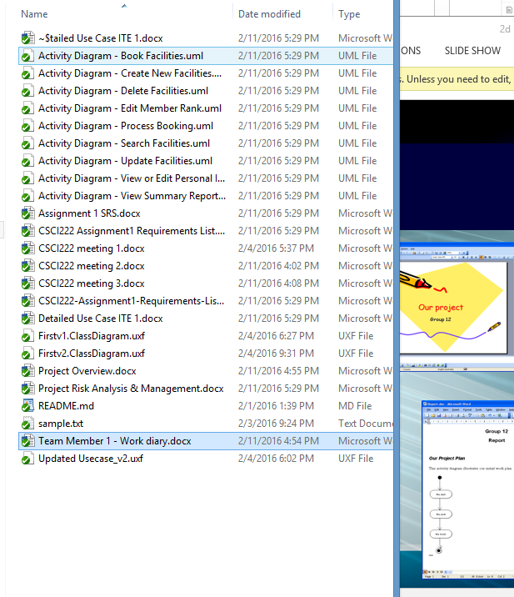

Screenshot #5 - Example using VCS's to **display the change history / log** (it may be necessary to do >1 screen capture, depending on the software used)

